**PROGRAM 1**

#include<stdio.h>

void main(){

int a=29,b=25,mul;

mul=a*b;

printf("%d",mul);

}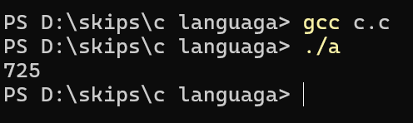

**PROGRAM 2**

#include<stdio.h>

void main(){

float m;

int k;

printf("enter kilometers to mile convert");

scanf("%d",&k);

m=k*0.621371;

printf("%f",m);

}

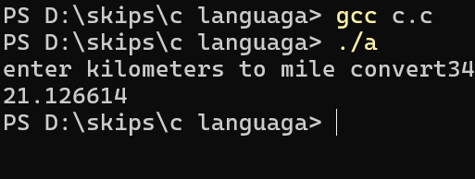

**PROGRAM 3**

#include<stdio.h>

void main(){

float a,b,h;

printf("enter high of triengle");

scanf("%f",&h);

printf("enter base of triengle");

scanf("%f",&b);

a=0.5*b*h;

printf("%f",a);

}

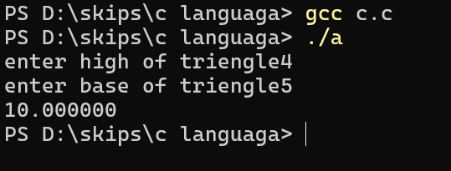

**PROGRAM 4**

#include <stdio.h>

#include<math.h>

int main() {

double PV, r, FV;

int n;

printf("Enter the present value: ");

scanf("%lf", &PV);

printf("Enter the annual interest rat: ");

scanf("%lf", &r);

r = r / 100;

printf("Enter the number of years: ");

scanf("%d", &n);

FV = PV * pow((1 + r), n);

printf("Future Value of Investment: %.2f\n", FV);

return 0;

}

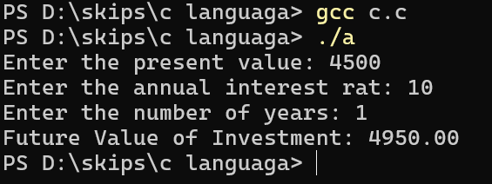

**PROGRAM 5**

#include <stdio.h>

int main() {

int a, b;

printf("Enter two integers: ");

scanf("%d %d", &a, &b);

if (a == b) {

printf("%d is equal to %d\n", a, b);

} else {

printf("%d is not equal to %d\n", a, b);

}

if (a > b) {

printf("%d is greater than %d\n", a, b);

} else if (a < b) {

printf("%d is less than %d\n", a, b);

}

if (a >= b) {

printf("%d is greater than or equal to %d\n", a, b);

}

if (a <= b) {

printf("%d is less than or equal to %d\n", a, b);

}

if (a != b) {

printf("%d is not equal to %d\n", a, b);

}

return 0;

}

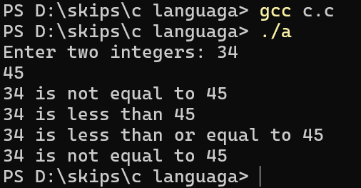

**PROGRAM 6**

#include <stdio.h>

int main() {

int number;

printf("Enter a number: ");

scanf("%d", &number);

if (number > 20 && number % 2 != 0) {

printf("%d is odd and greater than 20.\n", number);

} else {

printf("%d is not odd or not greater than 20.\n", number);

}

return 0;

}

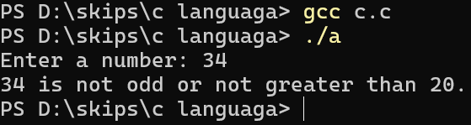

**PROGRAM 7**

#include <stdio.h>

int main() {

int age;

float annual_income;

int credit_score;

int stable_job_history;

printf("Enter your age: ");

scanf("%d", &age);

printf("Enter your annual income: ");

scanf("%f", &annual_income);

printf("Enter your credit score: ");

scanf("%d", &credit_score);

printf("Do you have a stable job history? (1 for Yes, 0 for No): ");

scanf("%d", &stable_job_history);

if ((age >= 21 && age <= 65) &&

(annual_income > 200000) &&

(credit_score >= 650 || (credit_score >= 600 && stable_job_history))) {

printf("You are eligible for a credit card.\n");

} else {

printf("You are not eligible for a credit card.\n");

}

return 0;

}

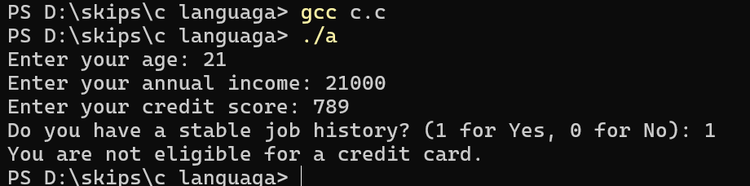

**PROGRAM 8**

#include <stdio.h>

int main() {

int age;

int health_check;

int reference;

int fitness_assessment_agreement;

printf("Enter your age: ");

scanf("%d", &age);

printf("Did you pass the basic health check? (1 for Yes, 0 for No): ");

scanf("%d", &health_check);

printf("Do you have a reference from a current member? (1 for Yes, 0 for No): ");

scanf("%d", &reference);

printf("Do you agree to undergo a fitness assessment? (1 for Yes, 0 for No): ");

scanf("%d", &fitness_assessment_agreement);

if ((age >= 18 && age <= 35 && health_check && reference) ||

(!health_check && reference && fitness_assessment_agreement)) {

printf("You are eligible for sports club membership.\n");

} else {

printf("You are not eligible for sports club membership.\n");

return 0;

}

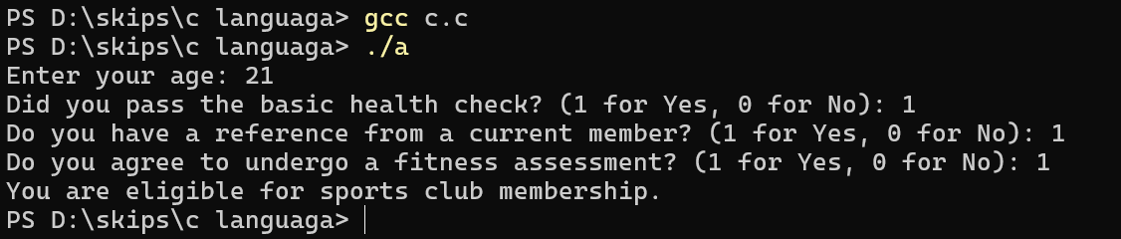

**PROGRAM 9**

#include <stdio.h>

#include <math.h>

int main() {

int z, terms;

printf("Enter the value of z: ");

scanf("%d", &z);

printf("Enter the number of terms to print: ");

scanf("%d", &terms);

printf("The series is:\n");

for (int i = 1; i <= terms; i++) {

printf("%d ", (int)pow(z, i)); // Calculate z^i

}

printf("\n");

return 0;

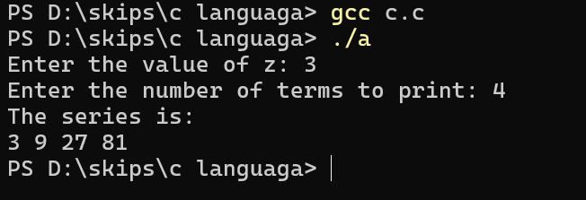

}

**PROGRAM 10**

#include <stdio.h>

#include <math.h>

int main() {

int z, terms;

printf("Enter the value of z: ");

scanf("%d", &z);

printf("Enter the number of terms to print: ");

scanf("%d", &terms);

printf("The series is:\n");

for (int i = 1; i <= terms; i++) {

int term = pow(z, i) + pow(i, 2); // Calculate z^i + i^2

printf("%d ", term);

}

printf("\n");

reurn 0;

}

